Superlige projekt

Claus Vestergaard Olesen

9/12/2019

Install the packages I need to move my data from the internet to R

## Loading required package: xml2

## -- Attaching packages --------------------------------------- tidyverse 1.3.0 --

## v ggplot2 3.2.1 v purrr 0.3.3  
## v tibble 2.1.3 v dplyr 0.8.3  
## v tidyr 1.0.0 v stringr 1.4.0  
## v readr 1.3.1 v forcats 0.4.0

## -- Conflicts ------------------------------------------ tidyverse_conflicts() --  
## x dplyr::filter() masks stats::filter()  
## x readr::guess_encoding() masks rvest::guess_encoding()  
## x dplyr::lag() masks stats::lag()  
## x purrr::pluck() masks rvest::pluck()

##   
## Attaching package: 'lubridate'

## The following object is masked from 'package:base':  
##   
## date

Link for my source for season 2016/17

SL1617 <- read_html("http://www.superliga.dk/performance-centre/2016-17")

Find my HTML code for the web site

SL1617 %>%  
 html_table()-> SL1617

Remove the data I have no use for. Collect the data I need in two tables: klub2 and restenaftabellen

SL1617[[1]] -> klub2

SL1617[[2]] -> restenaftabellen

Gather in a table called SL1617

bind_cols(klub2,restenaftabellen) -> SL1617

remove upper column

write_csv(SL1617, "SL1617.csv")

SL1617 <- read_csv("SL1617.csv", skip = 1)

## Warning: Missing column names filled in: 'X1' [1]

## Parsed with column specification:  
## cols(  
## X1 = col_double(),  
## Klub = col_character(),  
## Mål = col_double(),  
## `Mål imod` = col_double(),  
## Skud = col_double(),  
## `% boldbesiddelse` = col_character(),  
## `% afleveringer` = col_character(),  
## `Meter løbet` = col_character(),  
## Rødt = col_double(),  
## Gult = col_double()  
## )

Running the 2017/18 season

SL1718 <- read_html("http://www.superliga.dk/performance-centre/2017-18")

SL1718 %>%  
 html_table()-> SL1718

SL1718[[1]] -> klub

SL1718[[2]] -> resten

bind_cols(klub,resten) -> SL20172018

write_csv(SL20172018, "SL20172018.csv")

SL20172018 <- read_csv("SL20172018.csv", skip = 1)

## Warning: Missing column names filled in: 'X1' [1]

## Parsed with column specification:  
## cols(  
## X1 = col_double(),  
## Klub = col_character(),  
## Mål = col_double(),  
## `Mål imod` = col_double(),  
## Skud = col_double(),  
## `% boldbesiddelse` = col_character(),  
## `% afleveringer` = col_character(),  
## `Meter løbet` = col_character(),  
## Rødt = col_double(),  
## Gult = col_double()  
## )

ggplot(data = SL1617) +  
 geom_point(mapping = aes(x = Mål, y = Gult))

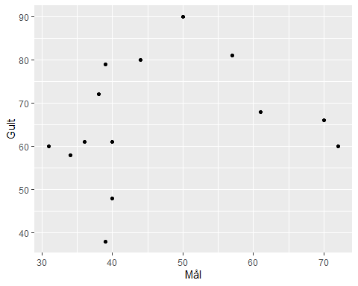

ggplot(data = SL1617) +   
 geom_point(mapping = aes(x = Mål, y = Skud, color = Klub))

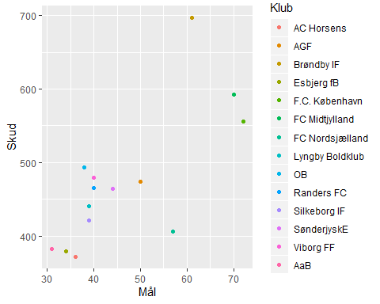

ggplot(data = SL20172018) +   
 geom_point(mapping = aes(x = Mål, y = Skud, color = Klub))

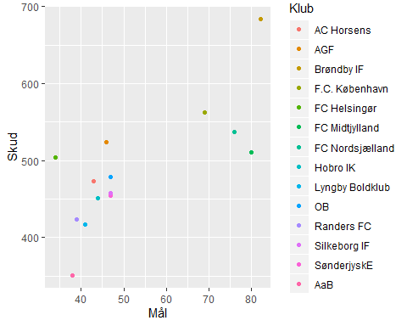

ggplot(data = SL1617) +   
 geom_point(mapping = aes(x = Rødt, y = Gult, color = Klub))

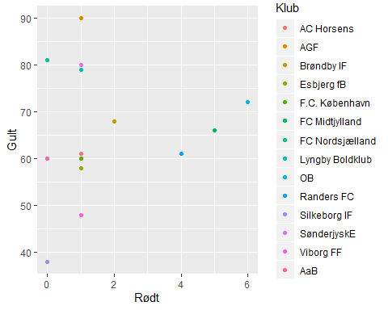

ggplot(data = SL20172018) +   
 geom_point(mapping = aes(x = Rødt, y = Gult, color = Klub))

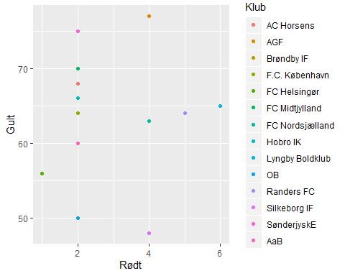

ggplot(data = SL1617) +   
 geom_point(mapping = aes(x = Skud, y = Rødt, color = Klub)) +  
 labs(x = "SL1617")

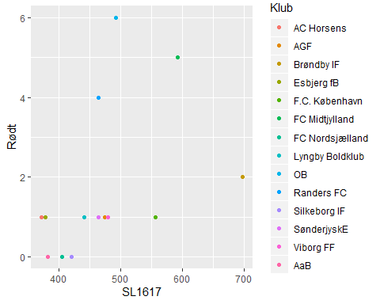

ggplot(data = SL20172018) +   
 geom_point(mapping = aes(x = Skud, y = Rødt, color = Klub)) +   
 labs(x = "SL20172018")

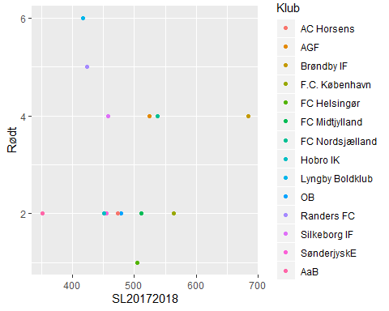

ggplot(data = SL1617) +   
 geom_point(mapping = aes(x = Mål, y = SL1617$`Meter løbet`, color = Klub)) +  
 labs(x = "SL1617")

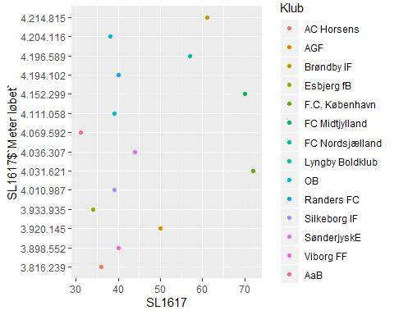

ggplot(data = SL1617) +   
 geom_point(mapping = aes(x = Skud, y = SL1617$`Meter løbet`, color = Klub)) +  
 labs(x = "SL1617")

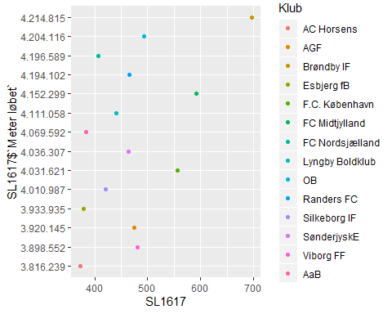

ggplot(data = SL20172018) +   
 geom_point(mapping = aes(x = Skud, y = SL20172018$`Meter løbet`, color = Klub)) +  
 labs(x = "SL20172018")

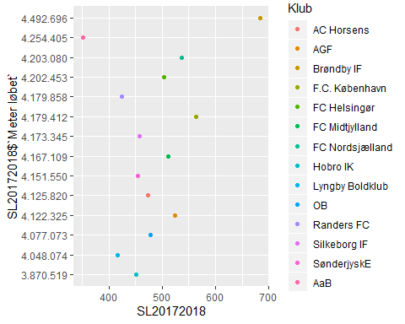

ggplot(data = SL1617) +   
 geom_point(mapping = aes(x = Gult, y = SL1617$`Mål imod`, color = Klub)) +  
 labs(x = "SL1617")

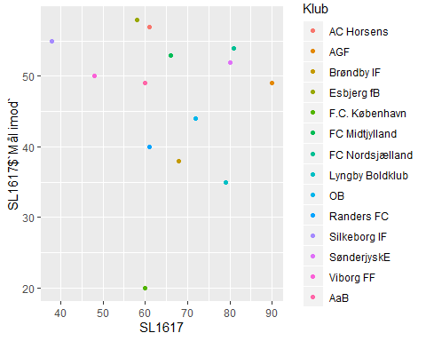

ggplot(data = SL20172018) +   
 geom_point(mapping = aes(x = Gult, y = SL20172018$`Mål imod`, color = Klub)) +  
 labs(x = "SL20172018")

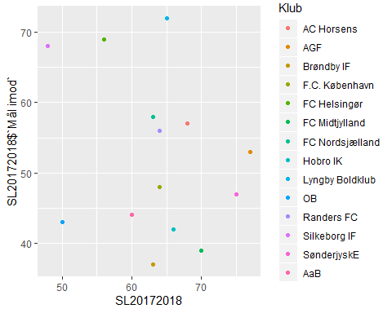

ggplot(data = SL1617) +   
 geom_point(mapping = aes(x = Mål, y = SL1617$`% boldbesiddelse`, color = Klub))

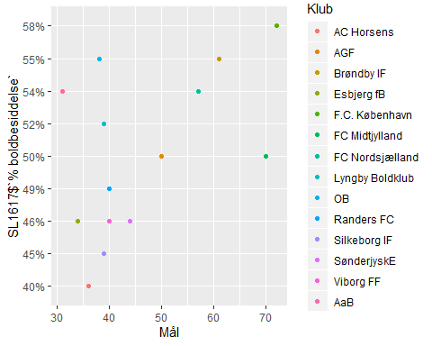

ggplot(data = SL20172018) +   
 geom_point(mapping = aes(x = Mål, y = SL20172018$`% boldbesiddelse`, color = Klub))

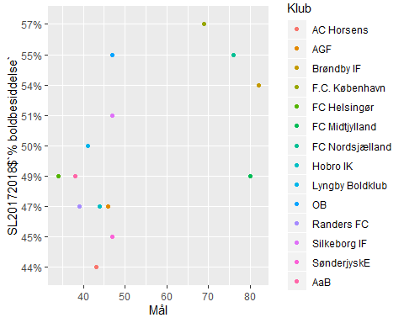

ggplot(data = SL1617) +   
 geom_point(mapping = aes(x = Skud, y = SL1617$`% boldbesiddelse`, color = Klub))

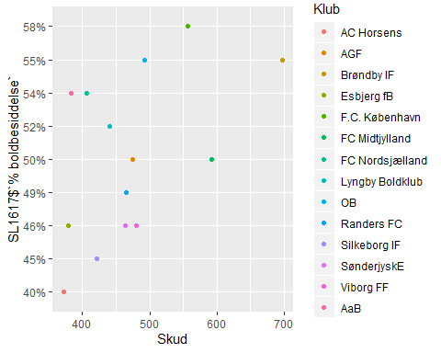

ggplot(data = SL20172018) +   
 geom_point(mapping = aes(x = Skud, y = SL20172018$`% boldbesiddelse`, color = Klub))

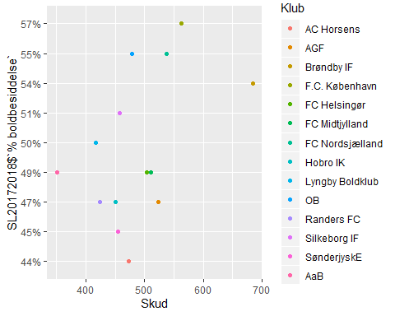

ggplot(data = SL1617) +   
 geom_point(mapping = aes(x = Skud, y = SL1617$`Meter løbet`, color = Klub))

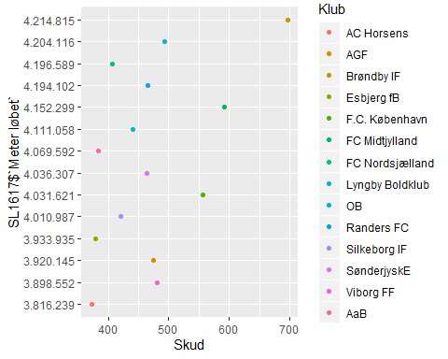

ggplot(data = SL20172018) +   
 geom_point(mapping = aes(x = Skud, y = SL20172018$`Meter løbet`, color = Klub))

